**A novel approach to early detection of dyslexia in children using VR Headset**

Aahan Mehta, Vikramjeet Singh, Reetu Jain

On My Own Technology Pvt. Ltd. Mumbai

**Abstract:**

This research explores the neurological disorder - Dyslexia, that mostly goes unidentified and undetected amongst school children. According to the Dyslexia Association of India, it's estimated that about 10 - 15% of school students have Dyslexia. As per the 2019 report of the Department of Biotechnology, approximately 35 million children in India seem to be having learning difficulties and the degree of this disorder may vary in students. Though early intervention can help students with dyslexia , several studies reveal issues pertaining due to the lack of proper screening and evaluation methods. Also these methods are not freely available in regional Indian languages. There are many research solutions to detect dyslexia using eye tracking with machine learning models and computer vision. While reading, the head and body movement does not give pure eye movement data, thus leading to inaccurate results. The high resolution cameras used for this are also expensive, which increase the market value of such products. Hence not easily accessible by all income groups. There is a need for a simple, cost effective and easy to use effective diagnostic tool to address this problem at the root level. The factors taken into account during the research study are age, frequency of words, font type and font size and local language.We have developed a classification model of eye tracking records with two minute duration using predictive and statistical sampling techniques. Our solution DDUET (Dyslexia Detection using Eye Tracking), directly tackles the issue by providing a Smart AI solution eliminating the head and body movement errors giving better accurate eye movement data while reading. DDUET has been found to be an effective, accessible and easily implementable solution for school and academic organizations. Our results show that DDUET is an effective means to identify children with reading difficulty who maybe at a risk of this disorder.

***Keywords: Dyslexia, Early Diagnosis, Eye movement, Eye Tracking, 3D plotting of eye movement, Machine learning, Computer vision.***

**Introduction**

Neurodiversity is a range of commonly co-occurring 'conditions' related to processing or cognitive differences. It includes Dyslexia, Autism, ADHD, and more. This study investigates eye gaze movements of neurodivergent children with different reading abilities to improve the quality of education to enhance their academic learning. The study highlights the use of eye trackers as a potential tool to aid in diagnosis of specific learning disabilities namely Dyslexia. The Eye tracker can be used as a futuristic technique / tool to identify early symptoms of dyslexia in children followed further by a psychometric test / evaluation. The identification and assessment of learning disabilities for children has become increasingly important in order to provide education that is appropriate for the child’s needs - for the psychological, social, and personal wellbeing. The main window of our brain functioning is the eye and differences in eye movement can reflect diseases or disorders in various functional areas of our brain. Today, Eye tracking is an increasingly important tool in psychology research. Eye tracking has been defined as “the study of the human visual system”. It examines eye movements while people perform tasks such as reading, comprehending text, solving problems and engaging in physical activities. It allows examination of different aspects of cognitive processing in moment-to-moment details and provides a neurobiological basis for cognitive processes.

This research focuses on the use of eye tracking for dyslexic individuals. As stated in UNESCO article “ it is important to note that dyslexia is not a visual impairment or eye movement problem. It stems from difficulties in phonological processing and word decoding. These difficulties, however, are reflected in disruptive eye movement patterns during reading, which makes eye tracking a useful method for identifying individuals at risk.” [6]

According to research, dyslexia affects 5- 10 percent of the world's population. This study demonstrates the potential to detect dyslexia in schoolchildren between the ages of 9 and 15 by utilizing eye tracking to examine the neural mechanisms behind reading comprehension. The majority of the existing screening techniques rely on written or oral exams. However, eye tracking is a natural way to objectively evaluate the reading process as it happens in real-time because it does not rely on the subject to give some overt verbal response. Our study is based on a sample of eye movement. These subjects were selected from local community, schools and NGO children of grade 3 to grade 10. We create classification models from eye tracking data with a period of less than a minute using predictive modeling and statistical resampling approaches, and we demonstrate that the models are very accurate at differentiating between high-risk and low-risk participants. Dyslexia is the most common of the learning disabilities and our results suggest that eye tracking can be a very efficient means to identify this disorder and to curb the long term risk of reading difficulties. It is observed that eye movement data along with machine learning can be used for building models of high predictive accuracy. The proposed model can be used as a screening tool for the diagnosis of dyslexia in schools.

**Learning Disabilities :**

Learning disabilities are disorders caused due to differences in the brain which affects the way the brain processes any information. These types of disorder had nothing to do with intelligence and mostly they are present at birth. There are certain factors that can play a role in the development of such learning disabilities. These factors include Genetics, Environmental exposures, and complications during pregnancy

Learning disability can be defined as dysfunction in the ability to read and understand spoken or written language, to do mathematical calculations, coordinate movements, or direct attention. Though it occurs at a very young age, it goes unidentified till the child is in school. Many times, it is diagnosed when the child reaches middle school and faces academic difficulties. This disorder affects the ability to learn in school, such as a lack of comprehension, slower comprehension, or weaker memory. A child with such a disorder may struggle with low self-esteem, frustration and other related problems.

These children often have normal intelligence and may try very hard to follow instructions and work hard at their academics. Their inability to master the subject matter affects their academic progress. The specific learning disorder may make teachers and parents concerned about their general intelligence or other cognitive abilities. It is found that 1 in 10 students have learning disorders. Individuals with Learning disability may not be able to eliminate the disorder but they can be mitigated with early interventions. If they are not treated early, they can have a “snowballing effect''. There are several types of learning disabilities - Specific learning disability (SLD), general learning disability (GMD), and attention deficit disorder with hyperactivity. Dyslexia is the most common learning disability.

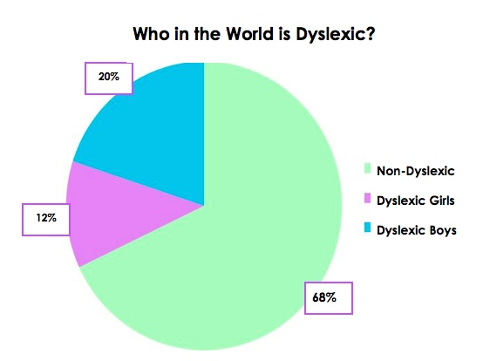

Here are some factors influencing the development of learning disorders:

* Family history and genetics.
* Prenatal and neonatal risks is another factor. In some cases,  poor growth in the uterus, exposure to alcohol or drugs before birth, premature birth, and very low birth weight are also found to be associated with learning disorders.
* Psychological trauma or abuse in early childhood.
* Physical trauma - especially head injuries or nervous system infections can play a crucial role in the development of learning disorders.
* Exposure to high levels of toxins.

Academic signs and symptoms of students with learning disabilities (for different age groups ranging from pre primary to highschool ) :

* Difficulty in identifying, word pronunciation or rhyming of words. Consistently errors in word pronunciation.
* Difficulty with alphabet, numbers, colors, shapes etc.
* Trouble in following directions, seeing time or remembering sequences.
* Issues with grip of using crayons, pencils, scissors, or line coloring.
* Struggle with buttons, zippers or in learning to tie shoe laces.
* Difficulty in connection between letters and sounds.
* Slow to learn new skills.
* Trouble learning basic math concepts.

* Problem with reading comprehension or basic math skills.
* Issues with word problem or open-ended test questions
* Poor or Lack of organizational skills.
* Dislike towards reading or writing or even poor handwriting.
* Difficulty in expressing one's thoughts aloud and following classroom discussions.
* Same word is read differently in a single passage.

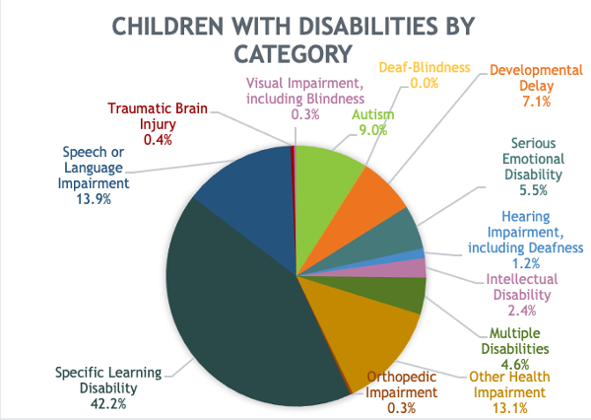

**DYSLEXIA :**

Dyslexia as a word is derived from two Greek words: dys (inadequate or lack of) and lexicon (word and/or verbal language).  Being Neurological in origin, this is a lifelong condition but can be overcome with the use of specialized teaching methodology and techniques.

https://www.dyslexiaindia.org.in/what-dyslexia.html

According to the INTERNATIONAL DYSLEXIA ASSOCIATION - “Dyslexia is a specific learning disability that is neurobiological in origin. It is characterized by difficulties with accurate and/or fluent word recognition and by poor spelling and decoding abilities. These difficulties typically result from a deficit in the phonological component of language that is often unexpected in relation to other cognitive abilities and the provision of effective classroom instruction. Secondary consequences may include problems in reading comprehension and reduced reading experience that can impede growth of vocabulary and background knowledge.”

(Adopted by the IDA Board of Directors, Nov. 12, 2002.)

Child with dyslexia does not imply that he / she possesses below average learning ability. Infact, there are facts that prove that many children and even adults with dyslexia are very bright. Early interventions are very essential for the bright future of such children.   If undetected, in the long run, the child may show signs of depression, low self-esteem and also behavior problems. Thus their growth and success in academics is jeopardized if not diagnosed early.

Signs of reading problems include the following:

* Problem with spellings
* Recognition and understanding of letters and words. Omitting letters and syllables within words.
* Problems in distinguishing shapes of letters or sounds that are similar like *b, d, p, q, m, n,* etc. Rotation of letters and recognition of letters that are in wrong positions.
* Fluency and speed of reading’
* Vocabulary skills.
* Reading at a particular pace and recalling exactly what is read.
* Making inferences based on their reading. Comprehending the text passage. Misunderstanding the content of the quoted text

The impact on a child with dyslexia depends on severity of the condition and remedial effectiveness and these parameters vary from one individual to another. The core issue they have is with reading words which further aggravates the difficulty with processing and manipulating sounds. Some dyslexic children with early intervention and right remedial education support do manage to learn early, spelling and reading tasks. As they progress in the academic years their challenges increase drastically. They experience more complex language skills like grammar , understanding of conceptual text, comprehending longer passages or writing essays. [9]

Research states that about 9- 10 % of the world population is affected by dyslexia regardless of the language or cultural diversities. The Research further indicates that around 10 – 15 % children in India probably suffer from dyslexia. These figures can even go up in our country India, as multilingualism can also impact on such learning issues. In India, the diagnosis of dyslexia has been incomplete because of the absence of standardized, validated assessment tools in regional Indian languages. Recently, National Brain research  center has developed DALI , an assessment tool for dyslexic persons. This is the first screening and assessment tool for dyslexia which is currently in 4 regional languages of India. Extension to other languages is in process. [10]

Dyslexia is often supplemented along with other specific learning difficulties, such as Dyscalculia, Dyspraxia, non verbal learning disability or Attention Deficit Disorder. This results in a variation in the degree and nature of individuals’ strengths and weaknesses. An association between dyslexia and attention deficit disorders (ADD) is very high -as out of 100 children with dyslexia, 46 are also reported to have ADD or attention deficit hyperactivity disorders (ADHD), manifesting lack of concentration and behavioral problems. [7]

**Testing for dyslexia -**

 Other learning disabilities besides Dyslexia include the following [8]:

**Dyscalculia** – a mathematical disability in which a person has unusual difficulty solving arithmetic problems and grasping math concepts.

**Dysgraphia** – a condition of impaired letter writing by hand—disabled handwriting. Impaired handwriting can interfere with learning to spell words in writing and speed of writing text. Children with dysgraphia may have only impaired handwriting, only impaired spelling (without reading problems), or both impaired handwriting and impaired spelling.

**Attention Deficit Disorder (ADD) and Attention Deficit Hyperactive Disorders (ADHD)** can and do impact learning but they are not learning disabilities.  An individual can have more than one learning or behavioral disability. In various studies as many as 50% of those diagnosed with learning or reading disability have also been diagnosed with ADHD.  Although disabilities may co-occur, one is not the cause of the other.

1. **DALI:**

The National Brain research center has developed DALI , an assessment tool for dylexic persons. DALI stands for Dyslexia Assessment for Languages of India. Most of the screening tools for dyslexia students are generally in english. This is the first screening and assessment tool for dyslexia which is in Indian regional languages. Currently the tools are available in Hindi, Marathi, Kannada and English and are being developed in other Indian languages. DALI Dyslexia tool for school teachers consists of two screening tools

1. JST (Junior Screening Tool) for classes (1-2) and

2. MST (Middle Screening Tool) for classes (3-5)

There are eight standardized and validated assessment Batteries to be used by psychologists.

In India nearly one in six children Nearly 1 in 6 children has reading problems. Dyslexia is a hidden learning disability wherein children fail to achieve reading skills in regular classroom settings. Dyslexia has a biological basis and occurs because of differences in brain wiring. Children in India receive education at school in at least 2 languages. It is necessary that the assessment of dyslexia be carried in all languages that the child is exposed to. In India, the diagnosis of dyslexia has been incomplete because of the absence of standardized, validated assessment tools in regional Indian languages. DALI (Dyslexia Assessment for Languages of India) contains screening tools for school teachers and assessment tools for psychologists to identify dyslexia. The tools are currently available in four languages as detailed below. Extension to other languages is in process. The DALI assessment and screening tool for Hindi, Marathi, Kannada and English is available for clinical use at the following website. [10]

**Literature Review:**

* + - 1. **DETAILED REVIEW OF VARIOUS METHODS FOR DYSLEXIA DETECTION ANALYSIS:**

People with dyslexia can largely learn how to examine, write and have a look at successfully after they use methods designed to their unique studying fashion. Based completely on current development in principle and dyslexia dimension techniques, the evaluation of eye movements has emerged as one of the primary methodological equipment in experimental reading research. For that reason, the research on dyslexia detection is gaining popularity, which is based on the picture processing concepts. In this evaluation work we try to discuss photo processing techniques, characteristic extraction and function choice, numerous category strategies utilized in photo processing. The bankruptcy also deals with mastering disability and its types, measures of eye movements and how they're related to dyslexia. The important issues and blessings of each approach are discussed honestly in these assessment paintings. Eventually overview work mentioned approximately the scope of the future and research gap.[1]

# **Detecting dyslexia in children using a computer-aided diagnosis system:**

Early detection is critical for early intervention to mitigate the effects of dyslexia. This paper offers a look at the usage of a laptop-aided machine, MyAddyXia, to diagnose dyslexia amongst youngsters. It makes use of five simple exams - Alphabet, pattern, arithmetic, route and phrase tests. Facts have been accumulated from 39 dyslexic children of the Dyslexia association of Malaysia (DAM). Those assessments diagnose the presence of reading and writing disabilities. The consequences of the examination confirmed that the Alphabet, arithmetic, and phrase tests had been best. The laptop literacy of the dyslexic youngsters and the remarks from the lecturers of DAM have been additionally highlighted.

1. **Present interview based diagnosis:**

A thorough conversation with the primary caregiver and a study of the student's academic records is used for diagnosis. These questions or a structured interview form with these sections may be used. advantageous (for instance, BASC Structured Developmental History (BASC:SDH). Following are the ways for diagnosis:

**Information on Cognitive Processing:** This includes Language, memory, auditory processing, visual processing, visual-motor integration, reasoning abilities, and executive functioning .

If reported by the school psychologist, subtest patterns of IQ tests can be used to infer cognitive processes. A difference in scores across subtests or groups of subtests points to a weakness in a particular area.

**Specific Oral Language Skills Related to Reading/Writing:** There are 2 main tests that comes under this category- Tests of higher level language skills and Tests of Auditory Processing/Phonological Awareness

**Educational Testing:** This is one of the most common tests that are used to diagnose or measure dyslexia in kids. It includes multiple tests like Word Reading and Decoding, Fluency (speed and accuracy of letter naming through passage reading) Oral and Silent Reading in context: evaluate rate, accuracy, and comprehension, Reading Comprehension, Spelling, Written Expression and Handwriting.

**Classroom Observation, Review of previous remediation strategies:** Direct observations in classroom. Behavioral assessment measures if behavior or attention/concentration are a concern: Conners Rating Scales (teacher and parent versions), Behavior Assessment System for Children (BASC; teacher and parent rating scales)

1. **Detection of Dyslexia using Eye Tracking Measures:**

According to this research, studies to identify these problems have been carried out taking into account a variety of criteria, including the reading times, fixation times, and number of saccades (rapid eye movements) of both impaired and non-impaired people, to produce the best findings. Thus, in order to identify and categorize people with and without dyslexia, we want to apply the same eye tracking technique assisted by machine learning models. Font size, typeface, frequency of words (non-impaired readers fixate on words more often if they are encountered less frequently), age (those with learning impairments tend to improve their reading skills with age), and other factors were taken into account during the study. [11]

1. **A study of Eye Tracking Technology and its applications:**

With the aid of eye tracking equipment, we can quantify eye movement activity. Eye monitoring informs us of our gaze locations. What is disregarded is the pupil's responses to various stimuli. Although the idea behind eye tracking is simple, there are many different ways it may be used and how it can be understood. The gaze points that our eye produces in relation to the head are measured by ET. Both remote and mobile eye trackers are available. It monitors and logs our eye movements as well as where we look. Software can be used to analyze, visualize, and understand this data. Eye tracking would also be a fantastic biometric instrument for analysis in a variety of applications. We have already discussed the typical use of fingerprint analysis and applications. In this essay, they talk about eye tracking technology and its varied uses. Almost every sector, including marketing, psychology, and human-computer interface, now employs ET. [12]

# **Advance Machine Learning Methods for Dyslexia Biomarker Detection: A Review of Implementation Details and Challenges:**

In order to help users of deep learning methods reach a clinically relevant and acceptable level, this review paper critically analyses new machine learning techniques for identifying dyslexia and related biomarkers and explores their limitations. The review is carried out under the assumption of implementation and experimental results for each of the 22 chosen articles using the Preferred Reporting Items for Systematic Review and Meta-Analyses (PRISMA) protocol with a view to highlighting some crucial challenges for achieving high accuracy and reliability of the most recent machine learning techniques.By providing a four-phase flow diagram of the selection process for the articles utilized in this review, PRISMA, an evidence-based protocol for reporting in systematic reviews and meta-analyses, contributes to ensuring the clarity and transparency of this paper. Therefore, it is anticipated that by resolving highlighted possible problems, deeper learning models for dyslexia and related biomarkers will be able to attain higher classification performance of clinical relevance. [13]

**Literature reviews to add (parts in red need to be reframed to avoid plagiarism):**

Research on Dyslexia Detection based on Eye

Tracking by Yu Zhang and Wangfang Zhou

This paper realizes eye tracking using computers as opposed to eye trackers. Their proposed model employs computer vision using Python and OpenCV library to detect the pupil and track its trajectory, establishes two indicators of reading speed and eye jump amplitude, analyzes the eye movement indicators using TOPSIS entropy weight method, and scientifically and reasonably distributes the weight comprehensive score. The subjects are given a time of 30 seconds to read 102 words. The text is different for different age groups. Then the model tracks the eye and obtains the reader's reading mode and reading speed through data analysis, and then determines the weight through mathematical modeling to evaluate their reading ability. Based on this evaluation, the reader finds out if they are at a low, medium low, medium high, or high risk of dyslexia. As of the publishing date, the model’s accuracy is 89.7%. The software can also perform training to improve reading ability of the user.

Based on convolution neural network, machine learning and computer vision, eye tracking is realized by using Python and OpenCV.

Detection of Dyslexia Using Eye Tracking

Boris Nerušil *,* JaroslavPolec Juraj Škunda

Our experiments were accomplished on a dataset containing 185 recordings of participants that was provided by previous researchers. Participants were categorized into two groups – High Risk (HR) and Low Risk (LR). 97 subjects (76 males and 21 females) were assigned to the HR group and 88 subjects (69 males and 19 females) were identified without dyslexia belonging to the LR group.

accuracy score of 96.2 % (STD ±3.2)

The paper notes the use of eye tracking in detection of several conditions such as Alzheimer’s Disease and Autism Spectrum Disorder with positive results.

The research used a 3 layered CNN for the classification. Within the CNN, Stochastic Gradient Descent algorithm with Momentum (SGDM)

**Research Methodology:**

**Objectives of the study:**

* To modify the VR headset for recording eye data by eliminating head and body movements to get pure eye movement.
* To have the test paragraph in multiple languages for a wider testing audience.
* To study the differences in reading patterns between dyslexic and non-dyslexic students.
* To analyze the data and come up with a ML classification model.

**Scope of the study:**

The scope of the study is the city of Ahmedabad and students between the age of 7 and 16.

**Data Source:**

All eye data collected was a primary data source. DDUET was a secondary data source.

**Sampling**:

The method of sampling is _____ and the sample size is 66. The age group of students is 7 to 16.

**Tools and techniques:**

The tool used for the collection of data was DDUET. The technique used was personal interview, to test the sample.

**Limitations:**

The limitations of the study is the city of Ahmedabad and students between the age of 7 and 16.

**~~Our solution~~ Analysis:**

Concept: There are several solutions available for learning disabilities diagnosis. Some are written or verbal tests and interviews whereas some are technical solutions that use Machine learning for diagnosis. Most technical solutions track the eye movement while reading and simultaneously record the subject’s voice as they read the text aloud. This makes it really difficult to detect the problem as high resolution cameras are needed. Moreover, movement of the head and neck adds up to decrease the movement of the eye. This increases the margin of error in the results.

Thus, to eliminate this error, “DDUET”(Dyslexia Detection Using Eye Tracking) provides clear and broadened eye movement for better and accurate diagnosis of the learning disabilities. It uses a VR Headset and a small camera with micro focal length which takes the video of the eye from a close distance when the user is reading the passage through the VR headset. This solution eliminates all the neck and head movements and provides very distinctive and clear eye movement of the patient.

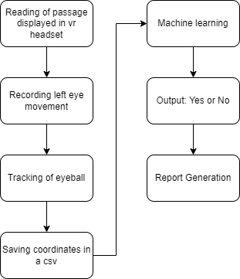

Prototype :

DDUET (The prototype) has been made by modifying a VR Headset. DDUET is a hollow VR headset from where the lenses have been removed. A hole has been made for the wire camera to go in and record the video of the eye. The camera is fixed on the top front of the VR box. And there is a phone holder in the VR box. as shown in the pictures below

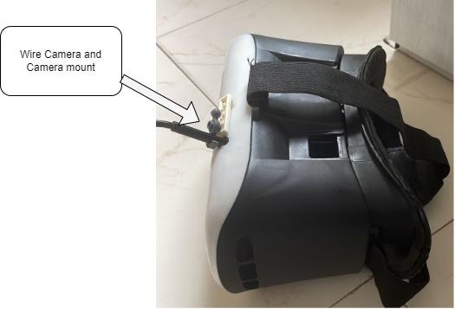

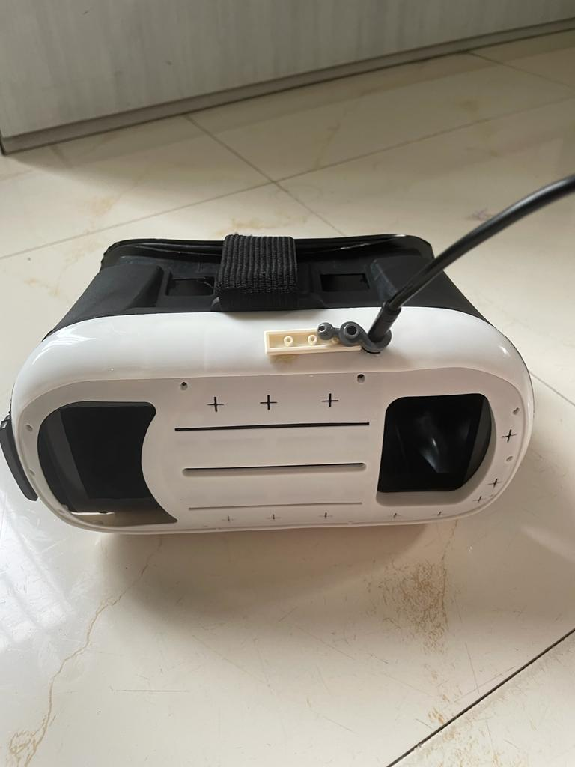

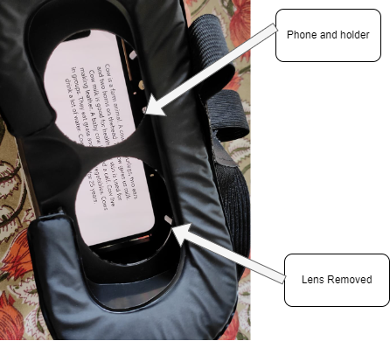

.

Our prototype DDUET helps us get a clear and focused video of the eye movement while the subject is reading a passage. We have made small and easy to read passages for the students according to their age. The passage covers the full area of the screen inside the VR Box so the eye has to make a full movement including left to right and up to down in a pattern.

**CAD Design:**

We have made a 3D CAD Model of the solution to show the real look of the final product that can be used as a single easy to use device. This prototype has been created by modifying a VR headset box with a wired camera installed in it. But we have made a real CAD model inspired by our prototype which can be seen it the pictures below:

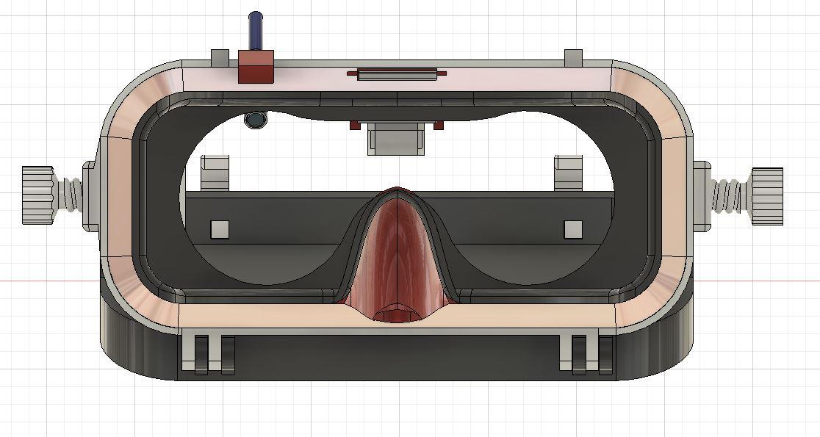

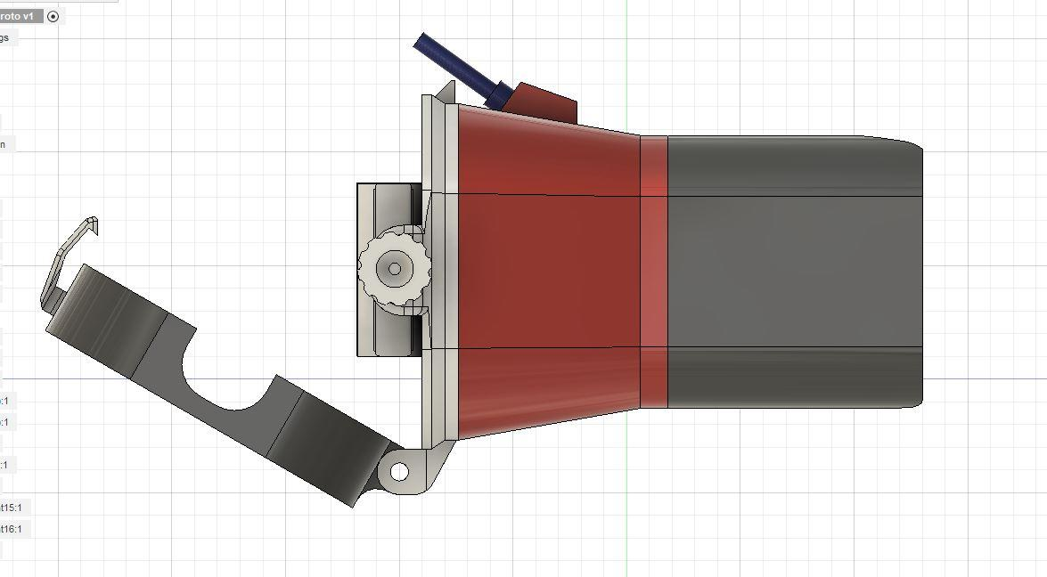

The camera is inserted into a hole at the top of the front side of the headset. This VR headset is just a case without any lenses for the subject to read the passage clearly and the camera can also focus on the eye without any interruption in between. We have tested it out in our prototype.

**Algorithm:**

**Detection Part**

· Libraries imported

· variables are defined.

· Cropping of video function is defined

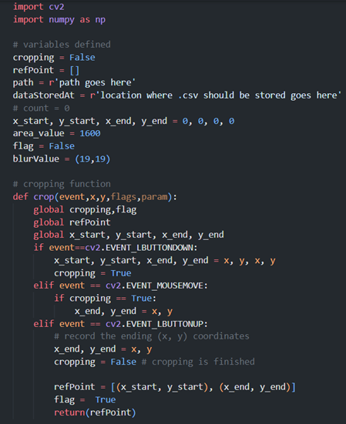

· Video is read by cv2

· Entire video is rotated by 90 degrees and saved, as it is originally recorded at a 90 degrees offset

· First frame is displayed, to crop out the other regions of the face. Only the eye region remains in the cropped portion (done manually)

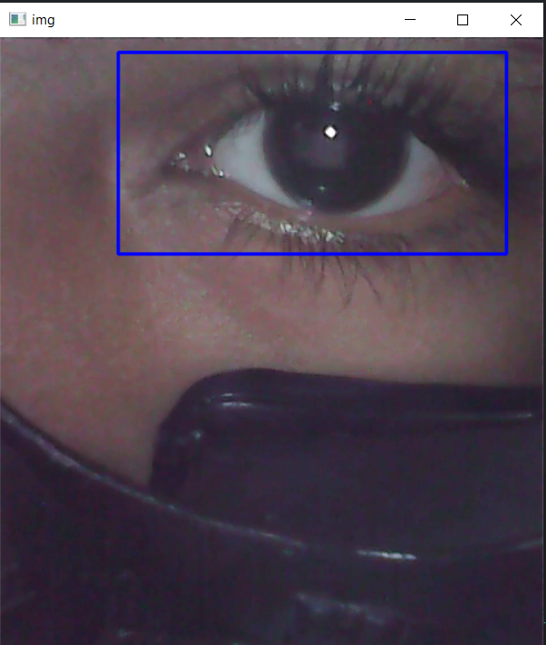

· Coordinates of the cropped part is stored using the crop() function, and from now on, the video is accessed only within these 4 coordinates

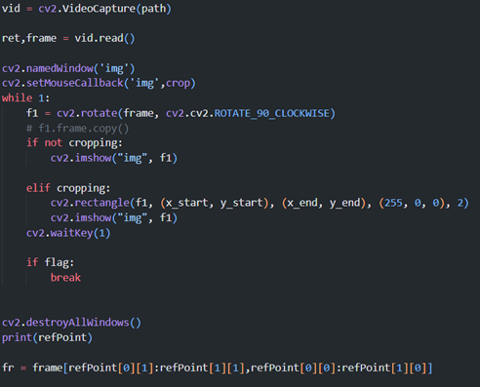

· First time the video is played. While the video is being played, a trackbar is displayed, from where the threshold value can be changed (manually) according to the requirement of the specific video to detect only the eye region. Default value is 35.

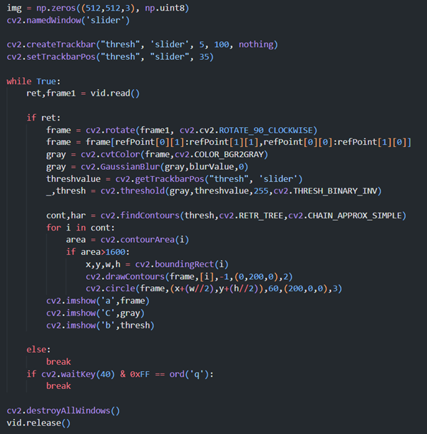

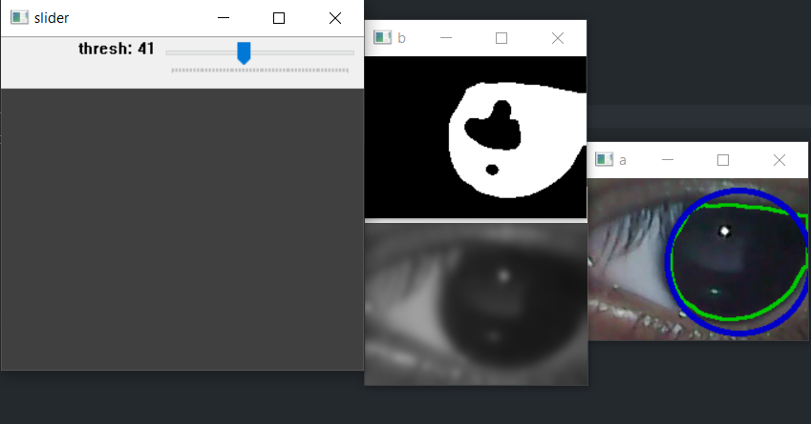

· Once the threshold value has been set, either wait for the video to end or enter ‘q’ on the keyboard to save the threshold value.

· Now the video is played the second time, where with the cropped region and threshold value, a circular contour is drawn over the iris and the coordinates of the center of the eye are saved in a .csv file. This is done actively while the video runs, frame by frame.

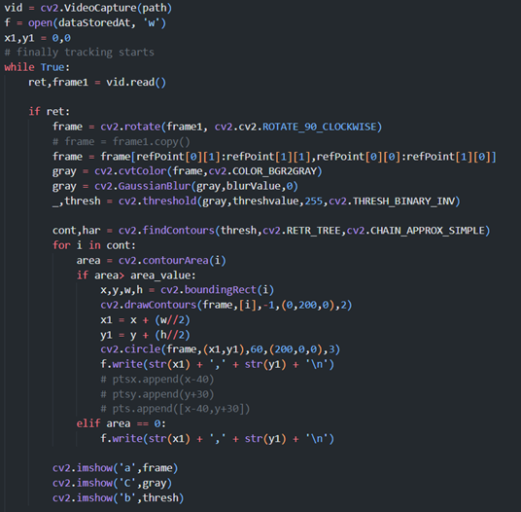

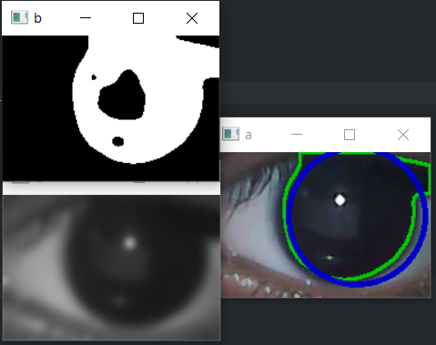

**Machine Learning:**

After getting the graphs and the eye movement values on the xy graph. We have saved all the data in the CSV files.

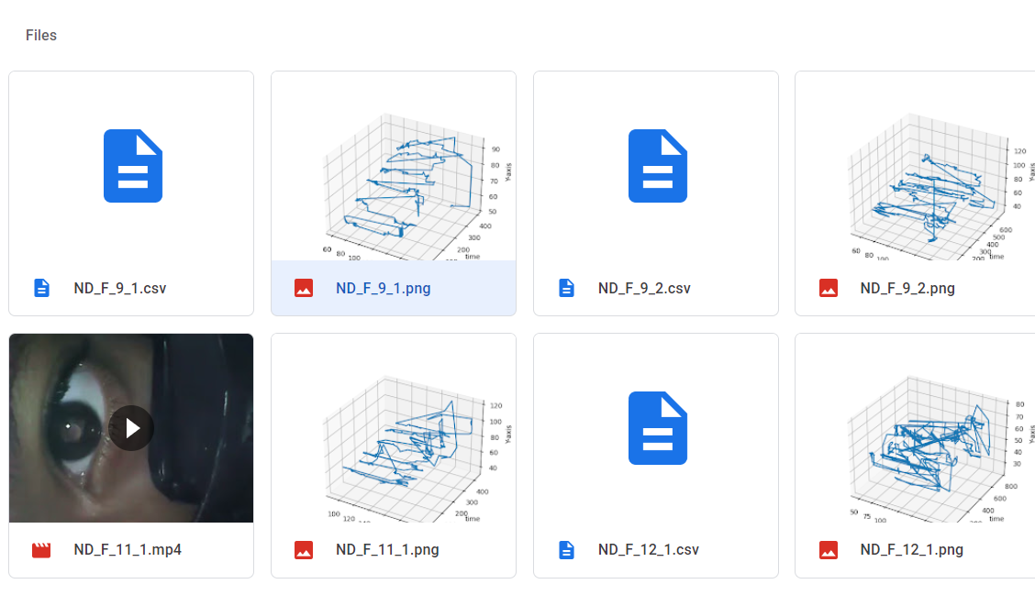

In that way we have collected multiple samples and created our dataset. After that we have tried 2 main machine learning algorithms to check the results. We tried Logistic regression and Support Vector Machine. And we found the Support Vector Machine Algorithm to be better and more accurate.

So the machine learning code is as follows:

After saving the data in the multiple csv files we have merged the data in single data frame and a single csv is created

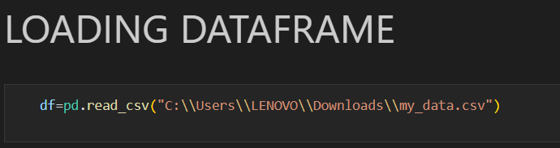

Checking the dataset

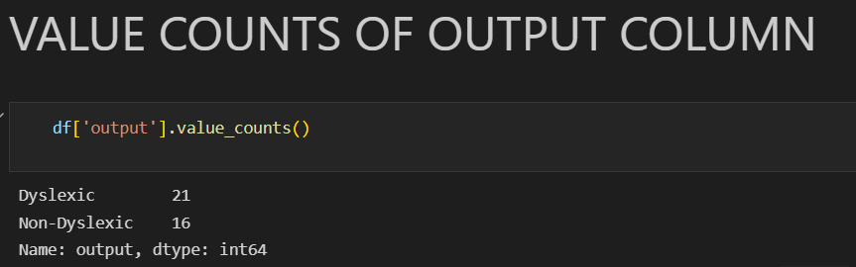

Manually encoded the class name string into integers

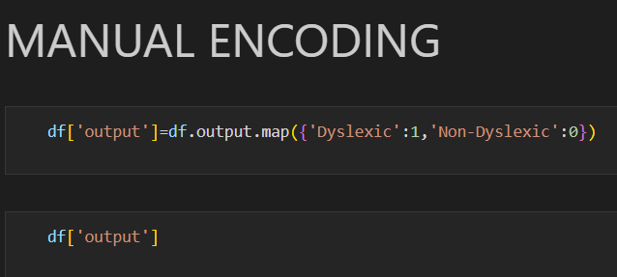

Splitting the data into test and train data

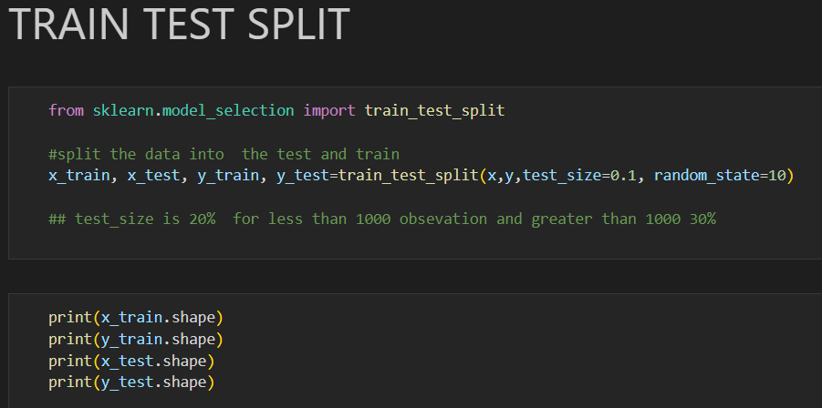

Implemented the SVM Model and training the model on the dataset created

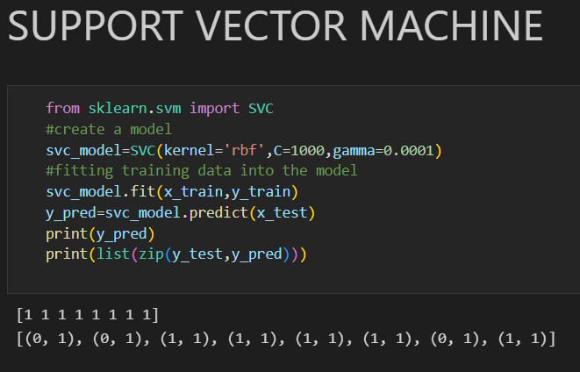

Checking the confusion matrix and the accuracy of the model:

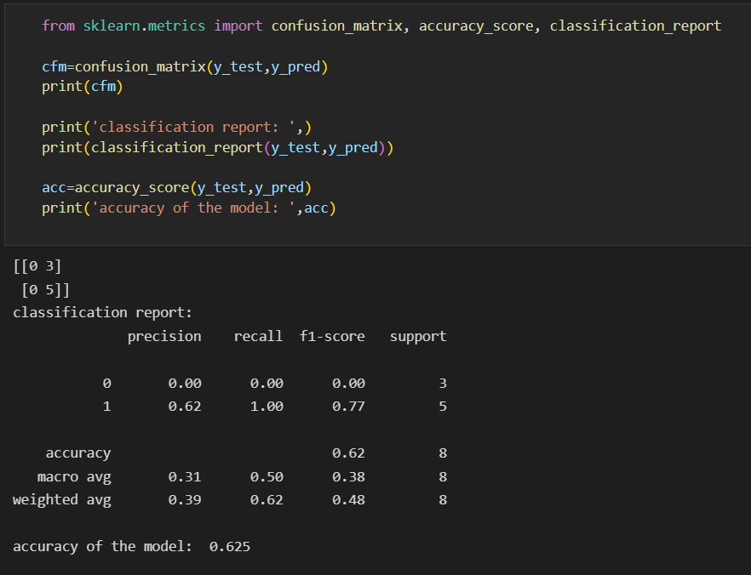

**PDF Report Part (done using FPDF library):**

We have made a program to generate a readable PDF report with the patient information

· Initialization of pdf

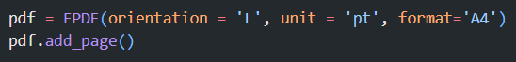

· Details of subject inputted, and written onto the pdf.

· .csv file of subject read

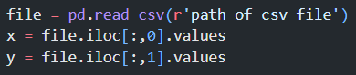

· Graphs of eye movement pattern generated and written onto the pdf

· TRUE/FALSE output for chance of dyslexia after machine learning model gives its result

· PDF is saved and shared with subject

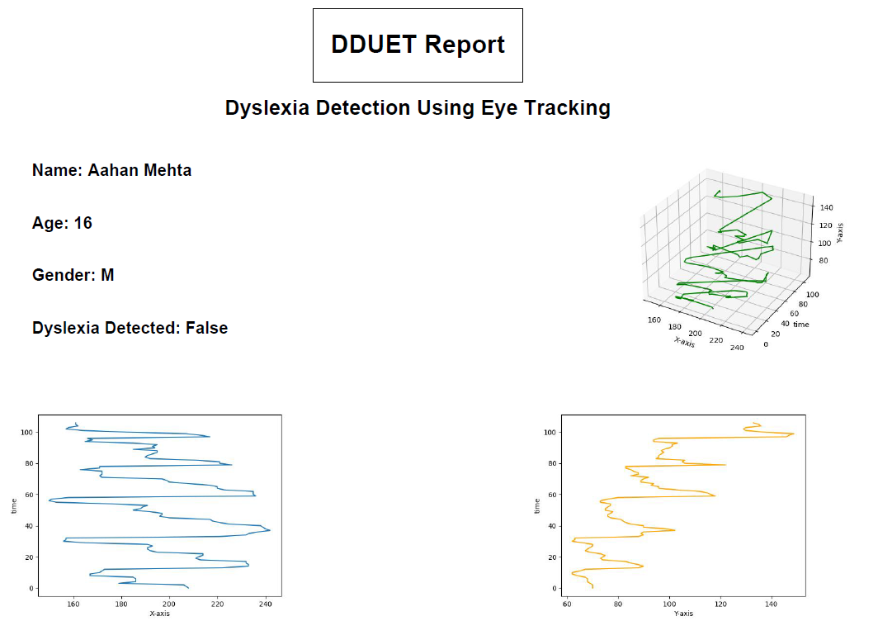

**Testing and Results:**

We collected data from 24 students with dyslexia and 24 students without dyslexia. Data collected was from NGOs only, as schools, due to security protocols, would not allow for data collection of their students.



**Conclusion:**

Many students struggle in their academic years due to dyslexia. It's important to have a simple efficient screening technique to facilitate early support to students with learning difficulties. Our investigation and results of using eye tracking methods reveal individual-level predictions with higher sensitivity than the conventional screening method of pen and paper.

We have created our own dataset, having tested our model multiple times on dylexic and non - dyslexic students. We have trained a machine learning model using Support Vector Machine Algorithm using this dataset.The model also provides a report with the 3 Dimensional representation of the eye movement with the time and XY Graph.

We can conclude that DDUET is our novel and easy accessible solution for early diagnosis of dyslexia and can be implemented on a large scale in various academic institutions.

The pandemic situation has impacted the learning curve of dylexic students due to discontinuation or disconnection from schools. Thus making it even a greater challenge, in a densely populated country like India to detect students with this disorder and be able to build upon their strengths in academic learning. Our solution DDUET can greatly help in dealing with the situation at the ground level. ~~DDUET will also promote exercises like Eye hand coordination exercise to help kids in learning. We think that Eye hand exercises should be a regular part of the curriculum.~~

**Future Scope:**

We have made a prototype which gives us really clear and extended eye movement by discarding the neck and the head movement with the help of a VR box. We see promising results from our program and the software solution. But there are lots of improvements that can be done to increase the implementability of the solution into an accessible product. So in the near future we will be working on field testing to increase our data set and also to check the reliability and the accuracy of the solution. Furthermore, we are working on the design aspect of the solution. We have made a CAD model to represent the final end product and we will be improving it to increase the ease of use and the comfort to wear. 3 to 4 students out of every 40 student classrooms have a chance of dyslexia and most of them go undetected. DDUET could help detect a chance of dyslexia in the students, through yearly testing to help make sure the students do not go undetected and can take the necessary steps required.

References:

1. Snowling MJ. Early identification and interventions for dyslexia: a contemporary view. J Res Spec Educ Needs. 2013 Jan 1;13(1):7-14. doi: 10.1111/j.1471-3802.2012.01262.x. PMID: 26290655; PMCID: PMC4538781.
2. Dr.P.M. Gomath, Dr.D. Karthika,”DETAILED REVIEW OF VARIOUS METHODS FOR DYSLEXIA DETECTION ANALYSIS” , <https://www.jetir.org/papers/JETIR1811212.pdf>
3. <https://www.dyslexiaindia.org.in/what-dyslexia.html>
4. Masooda Modak, Ketan Ghotane, Siddhanth V, Nachiket Kelkar, Aravind Iyer, Prachi G
5. <https://scroll.in/pulse/915366/what-is-dyslexia-and-why-is-narendra-modi-being-criticised-for-using-it-as-a-slur#:~:text=Between%205%25%20and%2020%25%20of,to%20have%20this%20learning%20disability>.

1. The D Labs team,”**What Eye Tracking Data Tells Us About Dyslexia”,** <https://mgiep.unesco.org/article/what-eye-tracking-data-tells-us-about-dyslexia>

1. Dyslexia Association of India, <https://www.dyslexiaindia.org.in/what-dyslexia.html>

1. TESTING FOR DYSLEXIA, <https://www.dyslexiaindia.org.in/pdf/test.pdf>

1. International Dyslexia Association, (<https://dyslexiaida.org/frequently-asked-questions/>)

* 1. National Brain Research Centre, <http://14.139.62.11/DALI/index.php>, <https://mgiep.unesco.org/article/dyslexia-assessment-for-languages-of-india-dali>

1. Masooda Modak, Ketan Ghotane, Siddhanth V, Nachiket Kelkar, Aravind Iyer, Prachi G, “Detection of Dyslexia using Eye Tracking Measures”, International Journal of Innovative Technology and Exploring Engineering (IJITEE) ISSN: 2278-3075, Volume-8, Issue- 6S4, April 2019, <https://www.ijitee.org/wp-content/uploads/papers/v8i6s4/F12080486S419.pdf>

1. Pramodini A. Punde, Dr. Mukti E. Jadhav, Dr. Ramesh R. Manza,”A study of Eye Tracking Technology and its applications”, 978-1-5090-4264-7/17/$31.00 ©2017 IEEE, <https://www.researchgate.net/profile/Mukti-Jadhav/publication/321407868_A_study_of_eye_tracking_technology_and_its_applications/links/612385411e95fe241aedd31c/A-study-of-eye-tracking-technology-and-its-applications.pdf>

1. Lateef, Usman & Muniyandi, Ravie & Omar, Khairuddin & Mohamad, Mazlyfarina. (2021). Advance Machine Learning Methods for Dyslexia Biomarker Detection: A Review of Implementation Details and Challenges. IEEE Access. PP. 1-1. 10.1109/ACCESS.2021.3062709.